Offers:

Offers tab contains four possible actions between two users. Any of this interactions can be accepted or rejected.

→ Add friend.

It sends “add friend” request to another user on a server (present server or any other server). If a request is accepted, new friend is added to our friend list. Otherwise any action isn't taken.

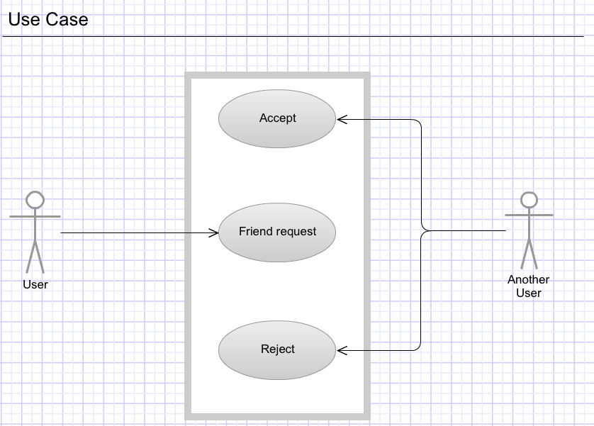

→ Fight

Sends fight request to another player from our friends list. (You have to specify amount of money you want to bet, monster you have picked). Your opponent has to accept your offer, otherwise any action won't be taken. If accepted monsters proceed to fight. After the fight a winner receives money reward and both sides receives experience points.

As a result of any fight your monster can be injured or die. Furthermore some or all of its attributes can be reduced.

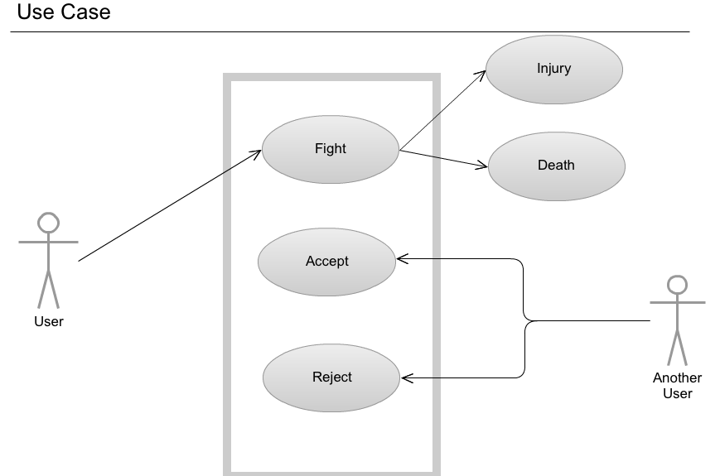

→ Breed

Sends breed request to another user from your friends list. You have to pick a monster you want to offer to breed and pick a monster from your friends list. If your offer is accepted new monster is created (his attributes depends on his parents attributes ). Otherwise nothing happens.

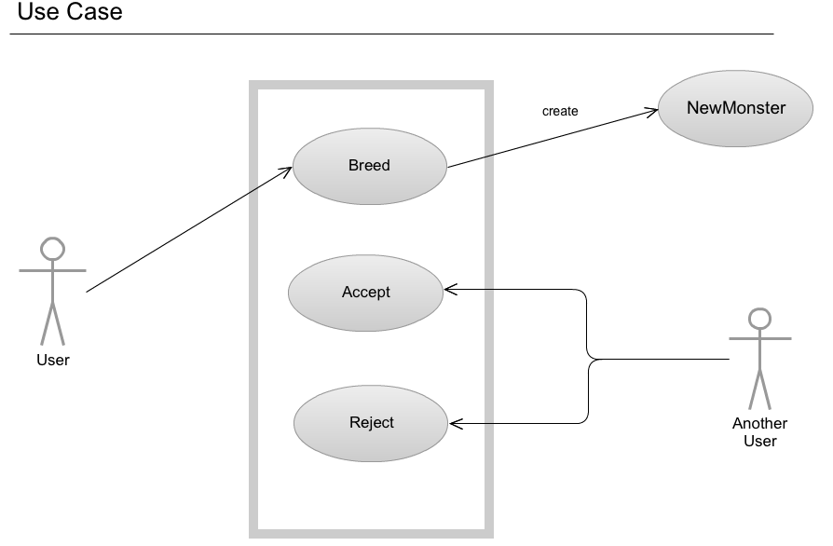

→ Trade

This interaction can occurs in three different cases.

First:
You may want to buy your friends monster. In this case you offer specified amount of money(I assume that every monster has it own value). If accepted, then monster is transferred to your monster farm and the other side receives payment.

Second:
You may want to swap monsters with your friend. In this case you pick monsters you want to swap. If your offer is accepted, replacement occurs.

Third:
You may want to sell your monster in order to get extra money. In this case you post your offer with a price. Request is sent to all users on your friends list. If any of them accepts your proposal sale occurs. Monster is transferred to your friend's farm and you receive payment.

